LAB 10
Write Python code to implement the following. Consider dataset files as “heart.csv”
- Convert text columns to numbers using label encoding and one hot encoding
- Apply scaling
- Build a classification model using various methods (SVM, logistic regression, random forest) and
- check which model gives you the best accuracy
- Now use PCA to reduce dimensions, retrain your model and see what impact it has on your model in terms of accuracy. Keep in mind that many times doing PCA reduces the accuracy but computation is much lighter and that's the trade off you need to consider while building models in real life.

import pandas as pd
import numpy as np

from sklearn.preprocessing import LabelEncoder, StandardScaler
from sklearn.model_selection import train_test_split
from sklearn.linear_model import LogisticRegression
from sklearn.svm import SVC
from sklearn.ensemble import RandomForestClassifier
from sklearn.decomposition import PCA
from sklearn.metrics import accuracy_score

df = pd.read_csv('heart.csv')
le = LabelEncoder()

for col in df.columns:
if df[col].dtype == 'object':
df[col] = le.fit_transform(df[col])

X = df.drop('HeartDisease', axis=1)
y = df['HeartDisease']

scaler = StandardScaler()
X_scaled = scaler.fit_transform(X)
X_train, X_test, y_train, y_test = train_test_split(
X_scaled, y, test_size=0.2, random_state=42
)
models = {
"Logistic": LogisticRegression(),
"SVM": SVC(),
"RandomForest": RandomForestClassifier()
}

print("Accuracy BEFORE PCA:")
for name, model in models.items():
model.fit(X_train, y_train)
y_pred = model.predict(X_test)
print(name, ":", accuracy_score(y_test, y_pred))

pca = PCA(n_components=5) # you can change components
X_pca = pca.fit_transform(X_scaled)

X_train_pca, X_test_pca, y_train, y_test = train_test_split(
X_pca, y, test_size=0.2, random_state=42
)

print("\nAccuracy AFTER PCA:")
for name, model in models.items():
model.fit(X_train_pca, y_train)
y_pred = model.predict(X_test_pca)
print(name, ":", accuracy_score(y_test, y_pred))

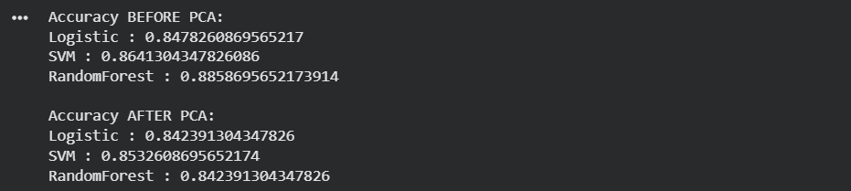
import matplotlib.pyplot as plt
# Reduce to 2 components for visualization
pca_vis = PCA(n_components=2)
X_vis = pca_vis.fit_transform(X_scaled)
# Plot
plt.figure()
plt.scatter(X_vis[:, 0], X_vis[:, 1], c=y)
plt.xlabel("Principal Component 1")
plt.ylabel("Principal Component 2")
plt.title("PCA Visualization of Heart Dataset")
plt.show()
